# Project Design Phase-I Solution Architecture

|  |  |
| --- | --- |
| Date | 13 OCTOBER 2022 |
| Team ID | PNT2022TMID02451 |
| Project Name | A Novel Method for Handwritten Digit Recognition System |

**Solution Architecture:**

Solution architecture is a complex process – with many sub-processes – that bridges the gap between business problems and technology solutions. Its goals are to:

* Input raw pixel values are provided as inputs.
* Convolution layer: Input layers translates the results of the neuron layer. There is a need to specify the filter to be used. Each filter can only be a 5*5 window that slides over input data and gets pixels with maximum intensities.
* Rectified linear unit(ReLU) layer: Provided activation function on the data taken as an image. In the case of back propagation ReLU function is used which prevents the values of pixels from changing.
* Pooling layer: Performs a down sampling operation in volume along the dimension(width, height).
* Fully Connected Layer: Score class is focused on a maximum score of the input digit is found.

# Example - Solution Architecture Diagram:

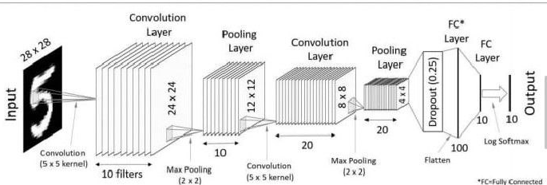

### *Figure 1: ARCHITECTURE FOR* Handwritten Digit Recognition System

**Reference: https://codetolight.wordpress.com/2017/11/29/getting-started-with-pytorch-for-deep-learning-part-3-neural-network-basics/**